**Python Basics Exercises**

**1. Simple Message**

**Task:** Assign a message to a variable and then print that message.

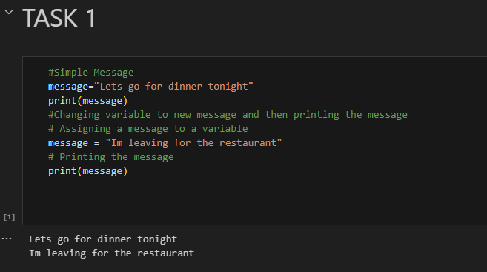

**2. Simple Messages**

**Task:**

● Assign a message to a variable and print that message.

● Change the value of the variable to a new message, and print the new message.

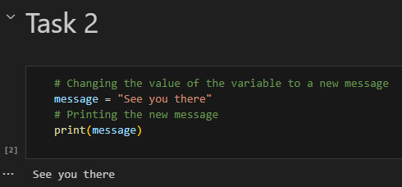

**3. Personal Message**

**Task:**

● Use a variable to represent a person’s name.

● Print a message to that person, such as, “Hello Eric, would you like to learn some Python today?”

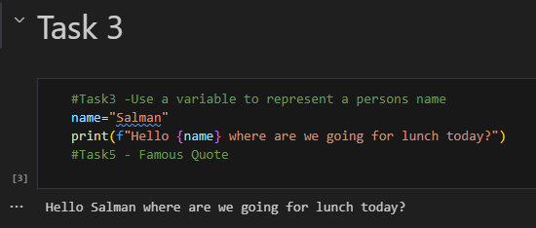

**4. Name Cases**

**Task:**

● Use a variable to represent a person’s name.

● Print the person’s name in lowercase, uppercase, and title case.

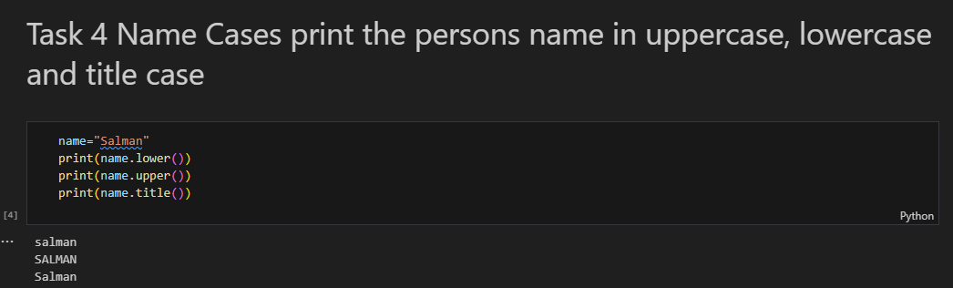

**5. Famous Quote**

**Task:**

● Find a quote from a famous person you admire.

● Print the quote and the name of its author.

The output should look something like the following:

Albert Einstein once said, “A person who never made a mistake never tried anything new.”

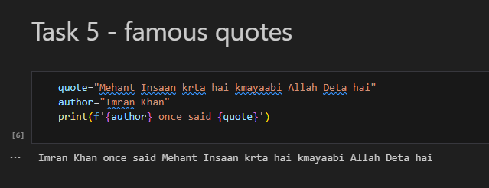

**6. Famous Quote 2**

**Task:**

● Use a variable called famous_person to represent the famous person’s name. ● Compose the message and represent it with a variable called message. ● Print the message.

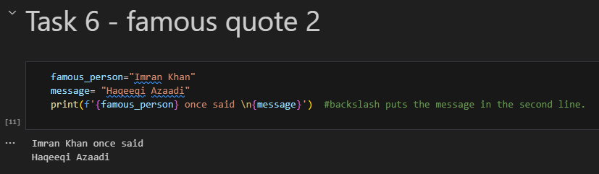

**7. Stripping Names**

**Task:**

● Use a variable to represent a person’s name, and include some whitespace characters at the beginning and end of the name.

● Make sure you use each character combination, \t and \n, at least once. ● Print the name once, so the whitespace around the name is displayed. ● Print the name using each of the three stripping functions: lstrip(), rstrip(), and strip().

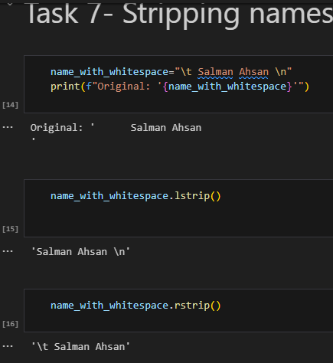

**8. Variable Sum**

**Task:** Assign the values 5, 10, and 15 to three variables x, y, and z. Print their sum

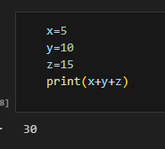

**9. Variable Swap**

**Task:** Swap the values of two variables a and b. Print the values before and after the sum

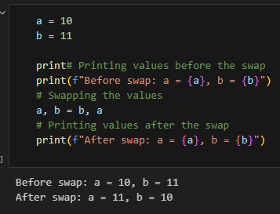

**10. Favorite Color**

**Task:** Create a variable with your favorite color and print it. Then change the variable name to something else and print the color again.

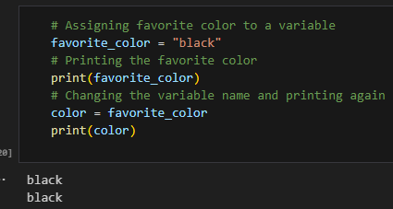

**11. Changing Pet Name**

**Task:** Create a variable pet_name and set it to "Buddy". Change the value of pet_name to "Max" and print the new value.

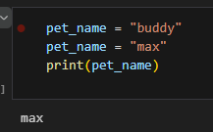

**12. Observing Name Error**

**Task:** Assign the value "Sunshine" to a variable and print it. Then, mistakenly try to print a variable with a different name (like sunsine) and observe the error.

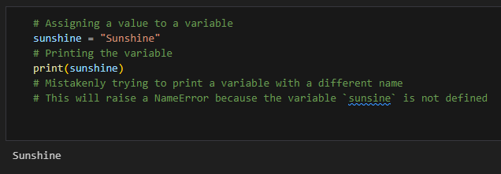

**13. Reassigning Score**

**Task:** Assign the value 100 to a variable score and print it. Then assign a new value to score and print it again.

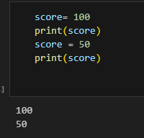

**14. City Name**

**Task:** Create a string variable city and assign it the name of a city you like. Print the city name.

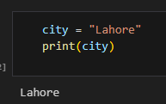

**15. Title Case Text**

**Task:** Create a variable text with the value "python programming" and print it in title

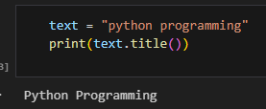

**16. Lowercase Conversion**

**Task:** Assign a string with mixed cases to a variable and print it in all lowercase

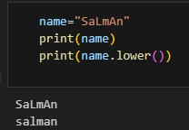

**17. Uppercase Conversion**

**Task:** Assign a string with mixed cases to a variable and print it in all uppercase

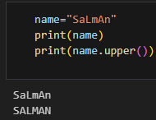

**18. Current Temperature**

**Task:** Create a variable temperature with the value 25. Print "The current temperature is [temperature] degrees." using the variable.

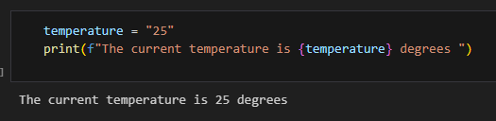

**19. Printing a Poem**

**Task:** Create a variable poem with a short poem that has multiple lines. Print the poem with each line starting on a new line.

